MANAVODAYA

EIGHT STEPS IN ACTION
- INCOME SHARING
True happiness comes from giving. This principle suggests keeping aside a fixed proportion of one’s income for a social cause annually. Many societies did have or do have such a tradition. This step proposes to revive such a tradition. One can start with small token contributions of 0.1 percent to 1 percent of annual income going up to 5 percent. Such contributions lead to a deep sense of fulfillment, if they ultimately reach those in need.

- TIME SHARING

Keeping aside a fixed proportion of one’s time for a social cause. This could be designed for a day’s involvement once in a few months or a few hours every week based on circumstances. Sharing skills, knowledge, even plain experiences without expecting any thing in return is equivalent to sharing human consciousness. This promotes trust in human relations, sensitivity and all round well being of everyone. Besides the consequences of building new forms of organisations appropriate for alternative living could be far reaching.
- SELF REFLECTION
Some separate time devoted to self-reflection everyday, gradually making it a way of life is the key to self evolution and meaningful transformation of one’s life. This helps in establishing long term goals, in taking important decisions and directing one’s energies towards more meaningful tasks. It also helps in elimination of individual faults and weaknesses.

- COLLECTIVE REFLECTION
A process of collective brainstorming that enables the participants to share perspectives relating to their values, choices and methods of decision making, leads to considerable changes in outlook, working and behaviour, if properly facilitated. There is an old Indian saying One cannot develop discretion without proper company ( Binu Satsang, vivek na hoi ) that needs appreciation and application. A small group of like-minded persons can start such an exercise. It is useful to maintain a certain regularity in such meetings even if they are at long intervals (say, once in a month / in two months / in three months).

- FAULT CONTROL
Everyone has faults and habits that one is not often happy with. One can identify and take steps to control such faults through self reflection.

Examples could vary from excessive alcohol or tobacco use to short temperament or laziness. Faulty earning, exploitative or dictatorial behaviour could be others. One should be able to define ones fault oneself and may take other opinions once in a while.

- SPEECH CONTROL
Speaking with conscious control and reflection is an important aspect of living that can be developed through practice.

- DOMESTIC RESPONSIBILITIES
Sharing of domestic responsibilities including those associated with child rearing is an important component of life discipline and enrichment. This aspect tends to be neglected by men due to established traditions. With changing roles and requirements of living, there is a need for conscious relook into this aspect with greater participation of men in domestic chores allowing women to participate more equitably in social and economic spheres.

8. LOCAL PURCHASE
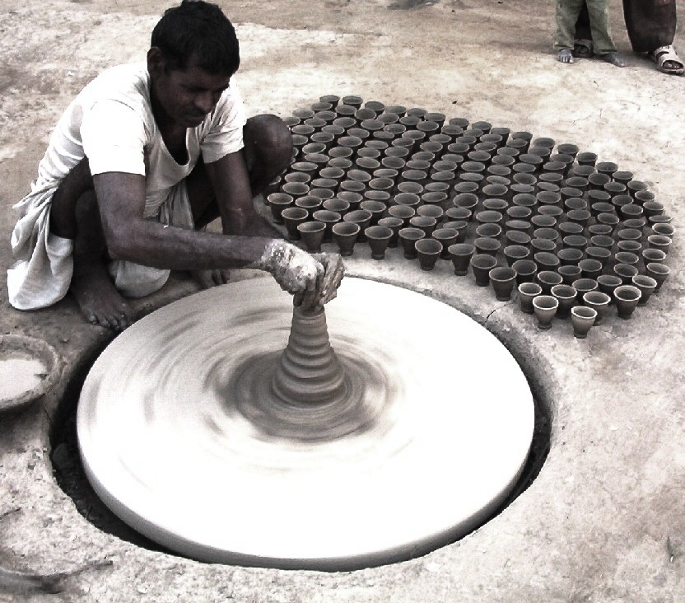Earmarking a certain proportion of total consumption to goods produced locally. This will help stimulate and strengthen small scale production wherever feasible and can be achieved without compromising on certain basic qualities of products. Without a conscious effort in this direction, many quality items produced locally go unnoticed at the cost of gainful employment to many. Such consumer awareness and action helps support cottage & small-scale industry in the face of global competition.

